

Annotation to project work
Name of project work: “Installation of heat recovery system in the ventilation system of office building М”
( ) Building, for example, insulation, window replacement, construction of a new energy efficient building
(Х) Electric energy, for example, lighting, compressed air, electric drives, refrigerating machines, load management
( ) Heat, for example, heating, industrial heat, heat return, ventilation / air conditioning technology, cogeneration
( ) Renewable sources of energy, for example, solar technology, wood energy, biogas, geothermal energy
( ) Management, for example, energy purchase, contracting, emission trading, energy resources data management system
  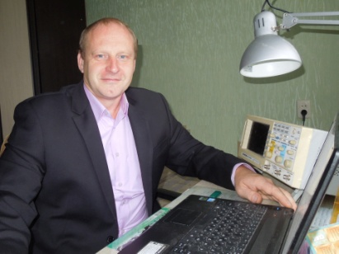  (Логотип) | Фотография  автора проекта | Company: CJSC “Polymeric Pipes Plant”  Industrial sector: construction  Products/services: pipe lines for heat supply systems  Number of staff: 345  Name and surname of the author of the project: Sergei Maksimov  Participant of EUREM courses №: 1  Contact information: +375297 46 48 68  zptenrg@tut.by

Description of the project:
Upgrading of cargo electric drive to loading crane КБ 100.0А by means of frequency converter installation for electric engine of crane winch. During replacement of parametric speed control system of electric motor drive for the system with frequency control we managed to decrease the static loses in an asynchronous motor and almost completely eliminate the dynamic losses associated with frequent starting and braking. Simplification of transient modes during starting (breaking) will also allow to It will also extend the service life of the crane mechanical components.
Scheme of installation:

Results:
Energy safety potential (kWh / year): 8125  Energy material: electricity  Costs saving potential (euro/year): 1 218,75  Potential for reduction СО₂ emissions (tones/year): 3.8 | Investment costs (euro): 5409  Payback period (years): 4,4  Probability of implementation:  (Х) high ( ) medium ( ) low

